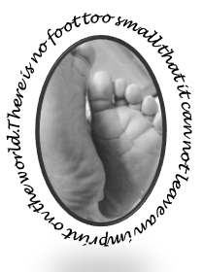
Marie’s Mission
Diaper Outreach Program
St. Michael’s on-the-heights Episcopal Church

Marie’s Mission by the Numbers
August was another great month for Marie’s Mission. On Saturday August 18th, the Mission distributed a record 107 Packages of diapers and wipes to 56 families!

Our Helpers
Our distribution day included many of our regulars along with some new volunteers.

Little Extras
We also distributed 36 backpacks and school supplies. We also gave out lots of baby clothes, donated by friends of the Mission.

What we Need
The most popular size this month were size 5 with 18 packages distributed. We continue to distribute pull-ups each month as our regular guests continue to grow. We gave out nineteen 4T-5T pull-up’s, ( 9 boys and 10 girls).

Amazon Wish List
For an easy way to donate check out the new Marie’s Mission wish list on Amazon. There is a link available on our webpage at mariesmission.org.

Reminders
- We had a fun” pack and pizza” lunch event on Saturday July 14th. Stay tuned for information on our next packing day event.
- Diaper Distribution occurs on the third Saturday of the month- next distribution date is September 15, 2018.

Marie’s Mission End of Summer Carnival Next Saturday
Marie’s Mission’s end of summer carnival on Saturday August 25, 2018.

