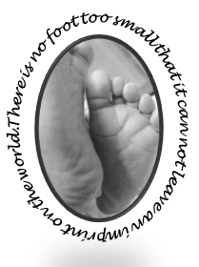
Marie’s Mission
Diaper Outreach Program
St. Michael’s on-the-heights Episcopal Church

Marie’s Mission by the Numbers
July was another great month for Marie’s Mission. On Saturday July 21st, the Mission distributed 97 Packages of diapers and wipes to 54 families!

Our Helpers
Our distribution day included many of our regulars along with some new volunteers. We had visitors from Catholic Charities here to observe our program and consider possibilities for future collaboration.

Little Extras
We also distributed children’s Swimmy diapers in sand buckets with shovels. We also gave out lots of baby clothes, donated by friends of the Mission.

What we Need
The most popular size this month were size six with 22 packages distributed. We continue to distribute pull-ups each month as our regular guests continue to grow. We gave out fifteen 4T-5T pullups, ( 5 boys and 10 girls).

Amazon Wish List
For an easy way to donate check out the new Marie’s Mission wish list on Amazon. There is a link available on our webpage at mariesmission.org.

Reminders
- We had a fun” pack and pizza” lunch event on Saturday July 14th. Stay tuned for information on our next packing day event.
- Diaper Distribution occurs on the third Saturday of the month- next distribution date is August 18, 2018.

Marie’s Mission Upcoming Events
Marie’s Mission is planning an end of summer carnival on Saturday August 25, 2018. Save the date.

