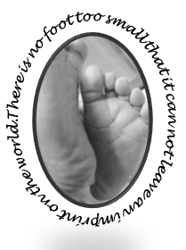
Marie’s Mission
Diaper Outreach Program
St. Michael’s on-the-heights Episcopal Church

Marie’s Mission by the Numbers
May was a great month for Marie’s Mission. On Saturday May 19th, the Mission distributed approximately 100 Packages of diapers and wipes! Also had a few people stop by last week (we try never to turn anyone away).

Our Helpers
We had a large group of volunteers helping with all aspects of the Mission, including assistance with the all-important set up Friday evening. In addition, we had about a dozen young people from the upcoming Confirmation group assisting in the distribution process!

Little extras
Our theme this month was dental health. We distributed children’s tooth brushes and toothpaste. We also gave out lots of baby clothes, donated by friends of the Mission.

What we need
The most popular sizes this month were size five and size six, with 20 packages of each distributed. We are also distributing more pull-ups each month as our regular guests continue to grow.

Thank you
Thank you to all who participated in our “Pizza and Pack” event on Friday May 4^{th. It} was a great success with over 30 people in attendance. Lots of diapers were packed and a lot of pizza consumed. Thank you to all who attended the Memorial service for Marie’s Grandfather, Kenneth Walker, and those who made donations to the mission in his name, both money and diapers.

Reminders
- Stay tuned for information on our next packing day event.
- Diaper Distribution occurs on the third Saturday of the month- next distribution date is June 16, 2018.

Marie’s Mission Upcoming events

Marie’s Mission is planning an end of summer carnival on Saturday August 25, 2018. Save the date.

