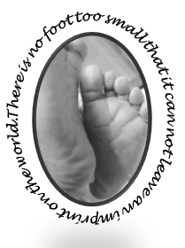
Marie’s Mission
Diaper Outreach Program
St. Michael’s on-the-heights Episcopal Church

Marie’s Mission by the Numbers
June was another great month for Marie’s Mission. On Saturday June 16th , the Mission distributed 103 Packages of diapers and wipes!

Our Helpers
Our distribution day volunteers included many of our regulars along with special guests The Reverend Jose Reyes Diocesan Missioner for Latino Ministries and his wife the Reverend Mary Rosendale Rector of Trinity Episcopal Church in Ware, MA. We were able to share ideas and insights with Mother Mary whose church hosts the Jubilee Cupboard Diaper Ministry.

Little Extras
Our theme this month was Summer. We distributed children’s Swimmy diapers. We also gave out lots of baby clothes, donated by friends of the Mission.

What we Need
The most popular size this month were size five with 24 packages distributed closely followed by size six with 22 and size four. We are also distributing more pull-ups each month as our regular guests continue to grow. We gave out 14 4T-5T pullups 7 boys and 7 girls.

Amazon Wish List
For an easy way to donate to Marie’s mission check out the new Marie’s Mission wish list on Amazon. There is a link available on our webpage at mariesmission.org.

Reminders
- Stay tuned for information on our next packing day event.
- Diaper Distribution occurs on the third Saturday of the month- next distribution date is July 21, 2018.

Marie’s Mission Upcoming Events

Marie’s Mission is planning an end of summer carnival on Saturday August 25, 2018. Save the date.

